Marketability Analysis and Opinion
Client: John Desautels, JD Concepts
Product(s): Enhanced Deck Assembly, Fascia Hinge Connections

Considerations: While all innovations and methods address a same or similar concern or problem, this report will focus on the innovation as described in Enhanced Deck Assembly Facilitation Methods and Systems.

Industry Analysis:
The core problem being addressed with these innovations is the tendency of two fascia boards (a component of decks, gazebos, etc perceived as largely aesthetic) to split, bend, and ultimately rot over time. These types of deteriorations affect the appearance of an individual's deck and home, thereby affecting its value, as well as leaving the internal structural components more susceptible to weather or other types of damage and wear.

Currently consumers are addressing this problem through a variety of approaches including the use of self-adhesive membranes, tape, glue, re-nailing, and‘“anti-miter” joints’. The self-adhesive membrane approach is intended to mitigate damage or decay to fascia by limiting the amount of moisture penetration into the construction materials. These solutions, while diverse, are generally insufficient in their success or are undesirable for other reasons. Use of membrane tape and building gaps between fascia and framing primarily address moisture and may not accommodate for other movement triggers like settling or expansions and contractions tied with temperature increases and decreases. Glue, re-nailing, and other types of adhesive tapes are all temporary solutions and primarily address the aesthetic component. Re-nailing the boards will likely result in later structural integrity issues due to the multiple nail holes being introduced; and replacing the boards may be unduly expensive when the damage is limited to their ends.

End user consumers, the individuals with the deteriorating decks, define the lifecycle of products that address the problem and the associated supply chain, to an extent. If the end user is an enthusiastic do-it-yourself (DIY) type, which may represent about one-third of online shoppers, they will likely proceed through many if not all of these solutions before looking for a more ingenuitive long term solution, such as that provided by this innovation. The sales resulting from this pathway will be realized by commercial hardware stores or other lumber and equipment retailers, see distribution of DIY sales at vendor type in Figures 2 and 3, below. Broader Market Share and Individual Chain Performance can be found in Figure 4. If the end user is less inclined to DIY activities they may engage a contractor and depending on the stage of deterioration and creativity of both the homeowner and the contractor, early solutions will likely be limited to the same undeserving options, again supporting a supply chain through retail lumber and hardware vendors.
Figure 1. Future attractiveness of online purchasing
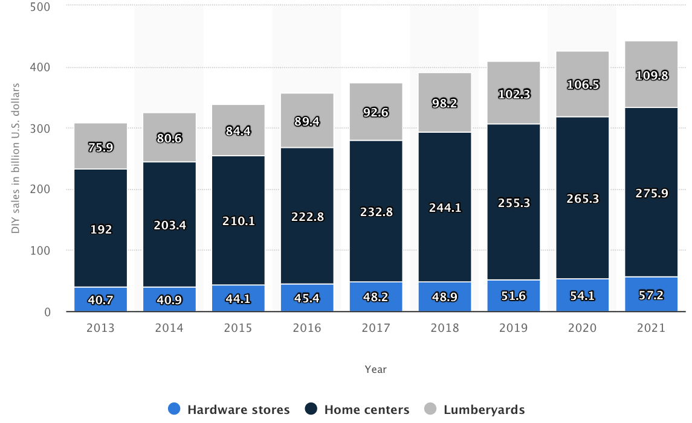
Figure 2. Do-it-yourself sales in the US from 2013-2021, by store type (in billion U.S. dollars)
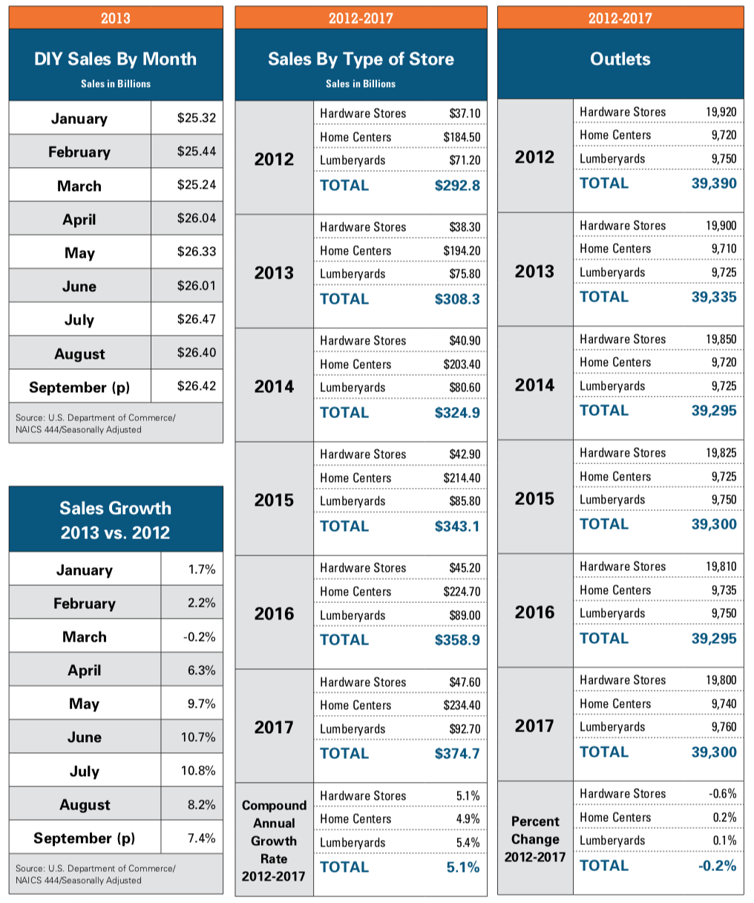
Figure 3. Do-it-yourself sales in the United States from 2012-2017 by Store Type
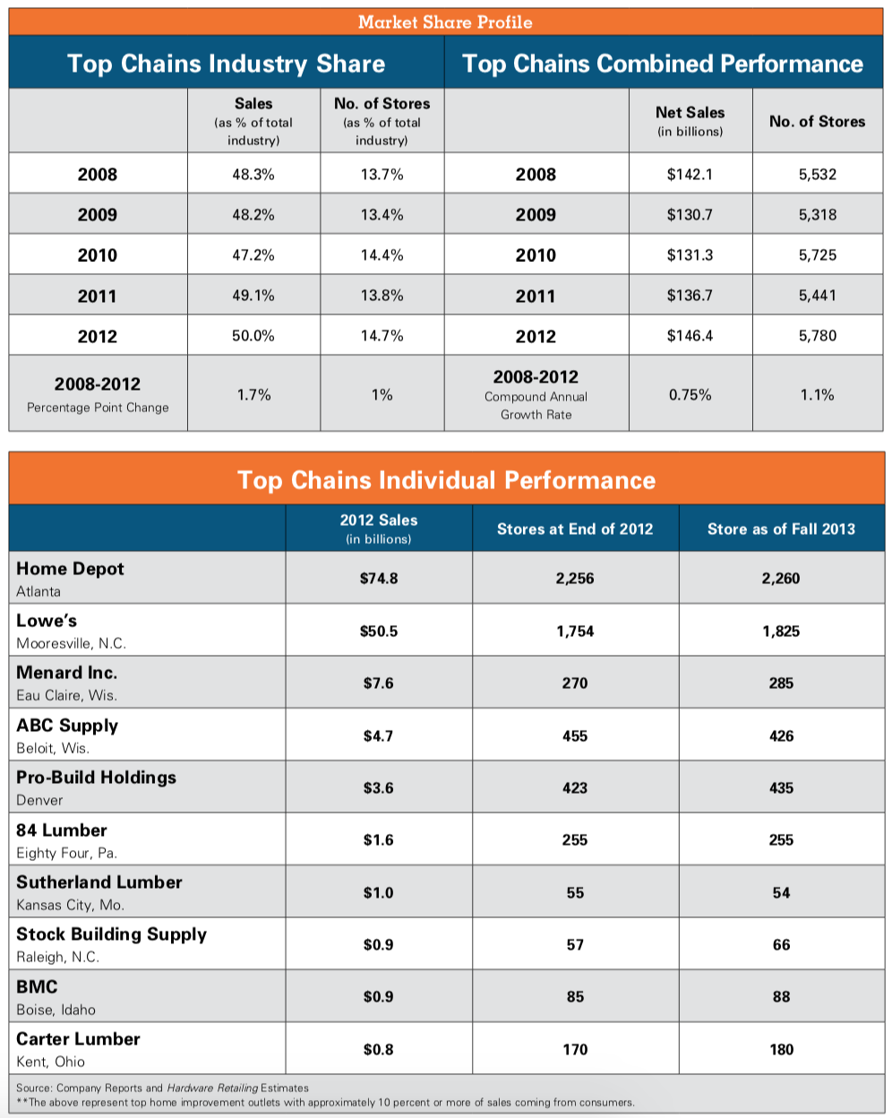
Figure 4. Market Share and Top Chain Performance for Hardware Industry

For the proposed innovation markets worth considering, then, should include the end user for DIY via hardware chains and online sales, contractor services/construction companies, or through both channels. For marketing and distribution direct to end user there would be considerations related to commoditization of the product (e.g. pre-configured or customized kits). For marketing and distribution partnerships with contractors or other commercial vendors more complexities may arise related both to customization potential and sourcing of related materials (e.g.. plates, fasteners, hinges).

Self-install kits could be configured as Hinge and/or Post. Where Hinge may include mounting layers (x2), hinge (x1), hinge fasteners (x10) per corner. And Post may include base plate (x1), base plate fasteners (x4), sleeve (x1), sleeve fasteners (x8) per corner. With add on products recommended for the Quarter Turn Accessory Attachment System.

While not the focus of this review, a Fascia Hinge Kit or Service is another innovation pathway with commercialization potential and is likely to require a more robust customer-client customization process. Hinge and Post self-install kits would require contracting or partnering with an Industrial Manufacturer. These partnerships may range in their complexity through supplementing sourcing capacity or raw production of materials. The sales of such a product may be more targeted toward repair and cover up or through custom contractor installs.

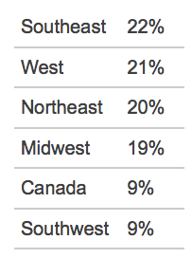
In 2008 residential markets claimed the largest share of decking demand and were projected to continue to grow through the interest of consumers in adding amenities to their existing construction including kitchens, railings, and gates. The projected growth in this industry is tied to the recovering housing market. Decking demand as measured by linear feet has been projected to increase from 3.3 billion lineal feet in 2008 to 3.55 billion linear feet by 2020 with wood decking products dominating the market. Regarding geography, the northwest is currently well-positioned for the solution granted through this innovation and as recently as 2004 the West (Figure 5) claimed 21% of the deck construction market in North America, valued at about $4 billion at the time. Related, figures detailing sales volume for Finish Carpentry Contractors in combined Washington, Oregon, and Idaho (Table 3) as well as those located only in Washington state (Table 4) are shown below.
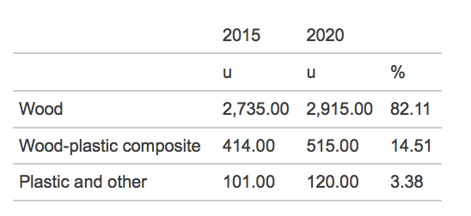
Table 1. Market Share for Deck Construction Table 2. Decking demand in millions of linear feet in North America, 2004
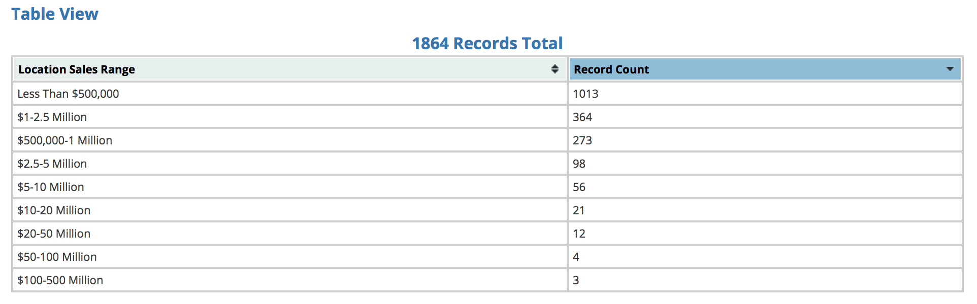
Table 3. Sales Volume (NAICS 238350) - Finish Carpentry Contractors, common keywords: deck construction, residential type. Washington, Idaho, Oregon.
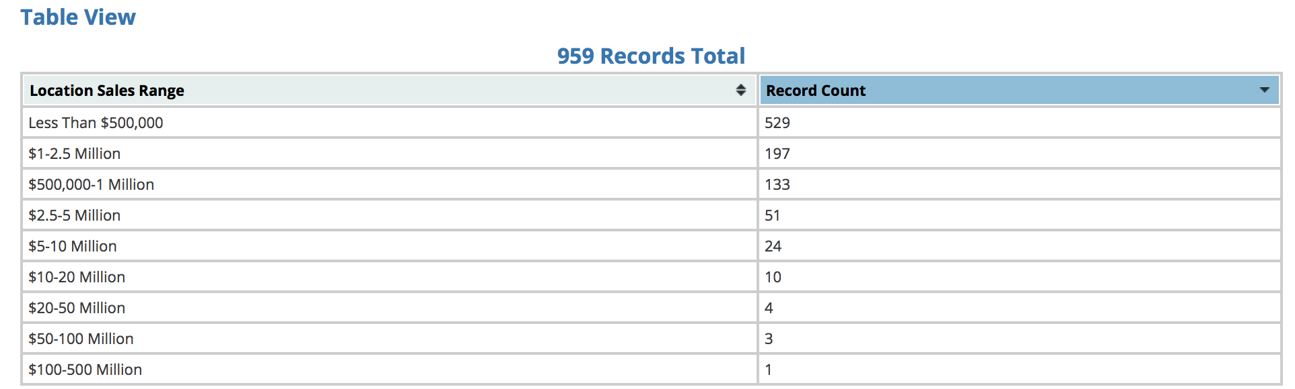
Table 4. Sales Volume (NAICS 238350) - Finish Carpentry Contractors, common keywords: deck construction, residential type. Washington.

Market Analysis:
As introduced above, the target client for this product may include the end user for DIY via hardware chains and online sales, contractor services/construction companies, or both. It will be important to decide in advance how many and which options to pursue. Once this determination is made it is recommended that planning center around identification and documentation of gaps in the current market, or channel. These gaps are likely to include, but not be limited to, complexity of installation, price of product, durability of product, and access to customized solutions. Other potential gaps that could affect retailer success in the distribution chain may arise from or be resolved through: vendor reputation, access to niche markets, and having contacts within key markets.

Current revenue for the deck and patio market is reported at $740m with an annual growth rate from 2012-2017 of 5.4%. It is also reported that this industry is expected to continue to expand, while at a slower pace than previous years due to deceleration in spending on home improvement.This projected growth is supported by recently observed trends in broader U.S. infrastructure spending which shows Amusement and recreation and Residential construction are the second and third fastest growing categories, respectively, Figure 7.

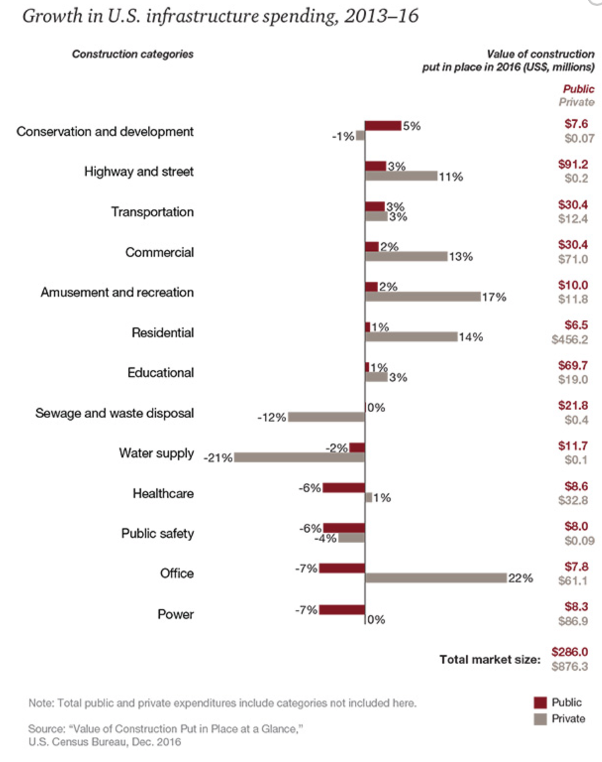
Figure 7. Growth in U.S. Infrastructure spending, 2013-2016

Another market factor is the frequency of homeowners within a region, as there is greater likelihood of DIY and home enhancement projects occurring at detached homes, which represent 63.4% of housing units in WA state between 2007-2009. This metric taken in consideration with home type, and rental to ownership statistics which in Seattle, WA suggest approximately 58% home ownership, reveal the regional customer base for this innovation .
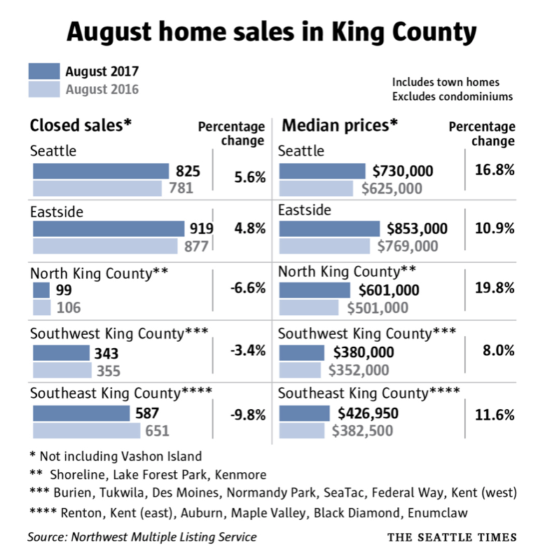

Figure 7. August [2017] home sales in King County

It has been reported that current home buyers are seeking larger, more lavish outdoor spaces. This is particularly good news for the Seattle area which is currently described as a ‘seller’s market’ with scarcity rapidly driving up interest and the associated prices. King County is experiencing increases in both frequency of closed sales and median prices, as shown in Figure 6, below. And while Seattle may currently be leading the pace in home sales, the number of homes to be sold nationally is projected to continue to increase, Figure 8.

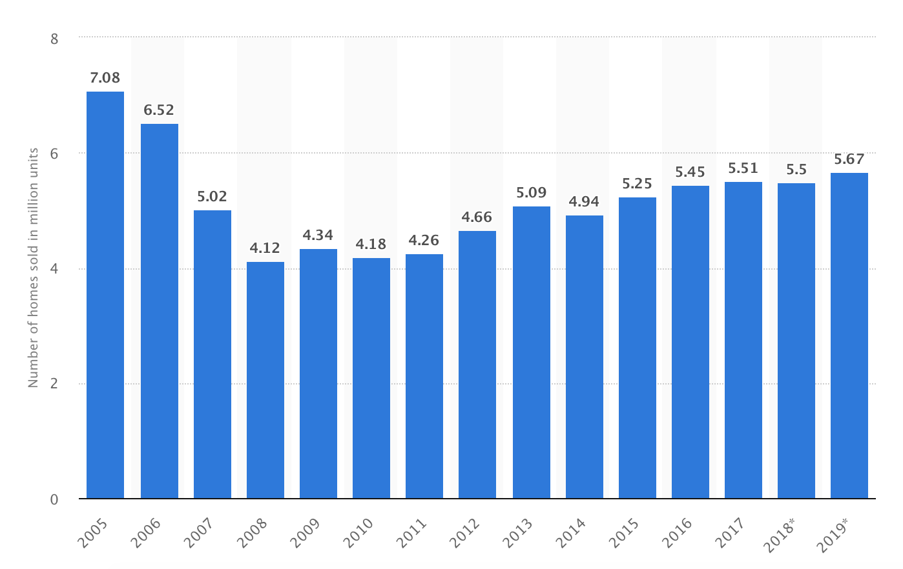

Figure 8. Number of existing homes sold in the United States from 2005 to 2019 (in million units)

Determining product or service competitors will depend on which market or channel approach is selected. It is unlikely any iteration of this product or service, particularly if commoditized as a kit, will have any initial direct competitors. This market or channel entry type is called “market-ready” and it is likely that all customers, either direct to DIY or partnerships with commercial and retail service providers will prefer a market-ready solution or sample offering. Strategic commercialization with this approach often benefits through use of industry-specific-adopters through product testing or promotional discounts. And as other product or service providers modify their current offerings to compete with these innovations it will be important to monitor products addressing, or even claiming to address, the problem in a similar manner to ensure ongoing competitive and cost supportive pricing.

Competitive Analysis
STRENGTHS | WEAKNESSES
Strengths: The Deck and patio construction industry is in the mature phase of its life cycle due to the industry’s services being accepted by the market and tied to US construction. This strength will provide more opportunities per capita in Seattle given recent market trends which indicate an increase of $109,000 (20%) in median home sales over the past year. Seattle market trends indicate an increase of $109,000 (20%) in median home sales over the past year. Given current trends and projections in home sales in the US, reference Figure 8, there is promise for successful distribution nationally. Regional figures, reference Figure 5, suggest distribution and marketing should be targeted toward coastal regions, Southeast, West, and Northeast (in that order). GREEN: green strengths mean very positive outlook for your product in the current market(s) and economy. This indicates that timing and market conditions are favorable for entry or growth for your innovation. | Weaknesses: Demand for deck and patio construction is highly correlated with the overall health of the housing market. This data point is unlikely to be a true weakness in King County at this time, but is certainly worth noting and considering for future business development planning. This weakness may be potentially mitigated by focusing on ease-of-use and price competitiveness of out-of-the box products targeted to DIY end users.This weakness is likely to be mitigated by projections for broader U.S. infrastructure investments which, while there has been general growth since 2016, future growth can be harder to predict. Investments in infrastructure are reported to be tied to the rise of oil prices and so are projected to increase at least through 2018. Based on recent dynamic activity of our government in domestic and national markets and activities, particularly with respect to oil, plans to mitigate this weakness may be challenging to define or follow. YELLOW: yellow weaknesses means few weaknesses have been identified in target markets for your innovation in its target market indicating this is a good time for entry or growth.
OPPORTUNITIES | THREATS
Opportunities: Industry operators have benefited from the economy’s overall expansion. The industry’s value add is expected to grow at annualized 1.7% with US GDP forecast to increase at annualized of 2% in the same period. This suggests that the deck and patio industry is projected to grow parallel to our overall economy and one may expect that as disposable incomes grow, so too will the size and complexity of decks and patios. This is supported by observations reported in the Wall Street Journal. YELLOW: yellow opportunities means that the future outlook for your innovation is bright and there are no obvious dangers to success of a well devised business strategy and launch. | Threats: Demand for deck and patio construction is highly correlated with the overall health of the housing market. Competition among industry participants will keep profit margins from experiencing any meaningful expansion. Consistent with the weaknesses of this industry, this threat is not likely to be true to the current market, at least regionally. GREEN: green threats suggest that there are few risks and those currently present for your innovation and/or markets of interest are low in their potential to interfere with carefully considered and deliberate market entry and distribution.

Competitiveness of this innovation in the available markets will be bolstered by early commoditization and productization of the innovation, such as through kits or through customized configurations. These customized configurations may manifest as both a service and a product offering where a DIY consumer provides project details (including but not limited to preferences, measurements, or other specifications). By distinguishing your innovation and focusing on its uniqueness, novel approach, and improved long-term results you will experience more success in the deck and patio construction industry, which itself, offers largely commoditized products through smaller industry participants.

Baldwin, J. (2017, May 31). No-Miter Method for Trimming Corners. Retrieved from http://www.deckmagazine.com/design-construction/decking/no-miter-method-for-trimming-corners_o
Bickford, C. (2017, Oct. 5). Durable Deck Details. Retrieved from: http://www.deckmagazine.com/design-construction/framing/durable-deck-details_o
Ed. Lazich, R. & Burton, V (2008). Decking Demand, 2008. Retrieved from: http://bi.galegroup.com.ezproxy.spl.org/global/article/GALE|I2502031182/4563ee88d8c9ec55962d9ca31a875f85?u=spl_main
Ed. Lazich, R (2015). Residential Decking Market, 2015. Retrieved from: http://bi.galegroup.com.ezproxy.spl.org/global/article/GALE|I2502049920/ab4b6ad5c54da54ee11932b32032c748?u=spl_main
Ed. Lazich, R. & Burton, V (2008). Decking Demand, 2008. Retrieved from: http://bi.galegroup.com.ezproxy.spl.org/global/article/GALE|I2502031182/4563ee88d8c9ec55962d9ca31a875f85?u=spl_main
Ed. Lazich, R. & Burton, V (2018). Decking Demand, 2015 and 2020. Retrieved from: http://bi.galegroup.com.ezproxy.spl.org/global/article/GALE|I2502058404/ab4b6ad5c54da54ee11932b32032c748?u=spl_main
Ed. Lazich, R. & Burton, V (2004). Deck Construction in North America, 2004. Retrieved from: http://bi.galegroup.com.ezproxy.spl.org/global/article/GALE|I2502025497/d87a260fa22ddbf7b4431e2d89b365c3?u=spl_main
Infogroup, Inc. (2018). Sales Volume NAICS 238350 (WA, ID, OR). Retrieved April 30, 2018, from ReferenceUSA database.
Infogroup, Inc. (2018). Sales Volume NAICS 238350 (WA). Retrieved April 30, 2018, from ReferenceUSA database.
Rosenberg, M. (2017, Sept. 6). King County home prices surge 18 percent, most on record for this time of year. Retrieved from: https://www.seattletimes.com/business/real-estate/king-county-home-prices-surge-18-percent-most-on-record-for-this-time-of-year/
IBISWorld. (2017, November). Deck & Patio Construction - US Market Research Report. Retrieved from: https://www.ibisworld.com/industry-trends/specialized-market-research-reports/specialist-engineering-infrastructure-contractors/general/deck-patio-construction.html
American Community Survey (2013, November) Washington State Data. Retrieved from: https://www.ofm.wa.gov/sites/default/files/public/legacy/pop/sdc/wa_state_housing_fact_sheet.pdf
IBISWorld. (2017, November). Deck & Patio Construction - US Market Research Report. Retrieved from: https://www.ibisworld.com/industry-trends/specialized-market-research-reports/specialist-engineering-infrastructure-contractors/general/deck-patio-construction.html
IBISWorld. (2017, November). Deck & Patio Construction - US Market Research Report. Retrieved from: https://www.ibisworld.com/industry-trends/specialized-market-research-reports/specialist-engineering-infrastructure-contractors/general/deck-patio-construction.html
Trulia (2018). Real Estate Data for Seattle. Retrieved from: https://www.trulia.com/real_estate/Seattle-Washington/market-trends/
IBISWorld. (2017, November). Deck & Patio Construction - US Market Research Report. Retrieved from: https://www.ibisworld.com/industry-trends/specialized-market-research-reports/specialist-engineering-infrastructure-contractors/general/deck-patio-construction.html
IBISWorld. (2017, November). Deck & Patio Construction - US Market Research Report. Retrieved from: https://www.ibisworld.com/industry-trends/specialized-market-research-reports/specialist-engineering-infrastructure-contractors/general/deck-patio-construction.html
IBISWorld. (2017, November). Deck & Patio Construction - US Market Research Report. Retrieved from: https://www.ibisworld.com/industry-trends/specialized-market-research-reports/specialist-engineering-infrastructure-contractors/general/deck-patio-construction.html
Chen, S. (2016, July 7). Luxury Homes Gain Over-the-Top Decks. Retrieved from: https://www.wsj.com/articles/luxury-homes-gain-over-the-top-decks-1467901935
IBISWorld. (2017, November). Deck & Patio Construction - US Market Research Report. Retrieved from: https://www.ibisworld.com/industry-trends/specialized-market-research-reports/specialist-engineering-infrastructure-contractors/general/deck-patio-construction.html
Statista (2016). Do-it-yourself sales in the United States from 2013-2021, by store type (in billion U.S. dollars. Retrieved from: https://www.statista.com/statistics/239770/diy-sales-in-the-united-states-by-store-type/
NRHA (2013) Market Measure: The Industry’s Annual Report. Retrieved from: http://www.hardwareretailing.com/wp-content/uploads/2013/11/Market-Measure-2013.pdf
NRHA (2013) Market Measure: The Industry’s Annual Report. Retrieved from: http://www.hardwareretailing.com/wp-content/uploads/2013/11/Market-Measure-2013.pdf
Sobolewski, M., Kent, A., Van den Berg, J. (2017) Engineering and Construction Trends, Growth in U.S. Infrastructure spending, 2013-2016. Retrieved from: https://www.strategyand.pwc.com/trend/2017-engineering-and-construction-trends
Chen, S. (2016, July 7). Luxury Homes Gain Over-the-Top Decks. Retrieved from: https://www.wsj.com/articles/luxury-homes-gain-over-the-top-decks-1467901935
KPMG (2013). Trends in Retail. Retrieved from: https://assets.kpmg.com/content/dam/kpmg/pdf/2013/12/trends-retail-2020-executive-summary-2013-kpmg.pdf
Sobolewski, M., Kent, A., Van den Berg, J. (2017) Engineering and Construction Trends, Growth in U.S. Infrastructure spending, 2013-2016. Retrieved from: https://www.strategyand.pwc.com/trend/2017-engineering-and-construction-trends
Ed. Lazich, R. & Burton, V (2004). Deck Construction in North America, 2004. Retrieved from: http://bi.galegroup.com.ezproxy.spl.org/global/article/GALE|I2502025497/d87a260fa22ddbf7b4431e2d89b365c3?u=spl_main
Ed. Lazich, R. & Burton, V (2018). Decking Demand, 2015 and 2020. Retrieved from: http://bi.galegroup.com.ezproxy.spl.org/global/article/GALE|I2502058404/ab4b6ad5c54da54ee11932b32032c748?u=spl_main
Statista (2017). Number of existing homes sold in the United States from 2005 to 2019 (in million units). Retrieved from: https://www.statista.com/statistics/226144/us-existing-home-sales/
Abodo. (2017). Where Renting Trumps Owning. Retrieved from: https://www.abodo.com/blog/where-renting-trumps-owning/

